Raster Data and Operations

**Learning Objective**

To introduce raster data, including elevation and land cover data sets. To introduce raster data manipulation, including mosaic, mask, projection. To introduce raster analysis, including terrain visualization and analysis, as well as map algebra. As a demonstration, you will work with elevation and land cover data for Delaware County, Pennsylvania.

First, complete the tutorial by following the steps below. Then, using the skills you’ve learned in the tutorial, complete the assignment given following the tutorial.

## TUTORIAL

## Acquiring the Data

We will work with elevation and land cover data, as well as municipal boundary data, for Delaware County, Pennsylvania.

**First, acquire the municipalities data.**

From [PASDA](http://www.pasda.psu.edu/), use the search function to find and download the following file:

* Pennsylvania municipality boundaries (2017)

**Next, acquire the elevation data.**

We will download raster elevation data from [The National Map](https://nationalmap.gov/) (<https://nationalmap.gov/>), the US federal data geoportal administered by the US Geological Survey (USGS).

1. Go to The National Map, click on Find Data + View & Download. Then, under GIS Data click on Download GIS Data to load the map viewer.
2. On the left side of the window, under Dataset click on Elevation Products (3DEP) and then check the box for 1 arc-second DEM. Uncheck the other boxes.

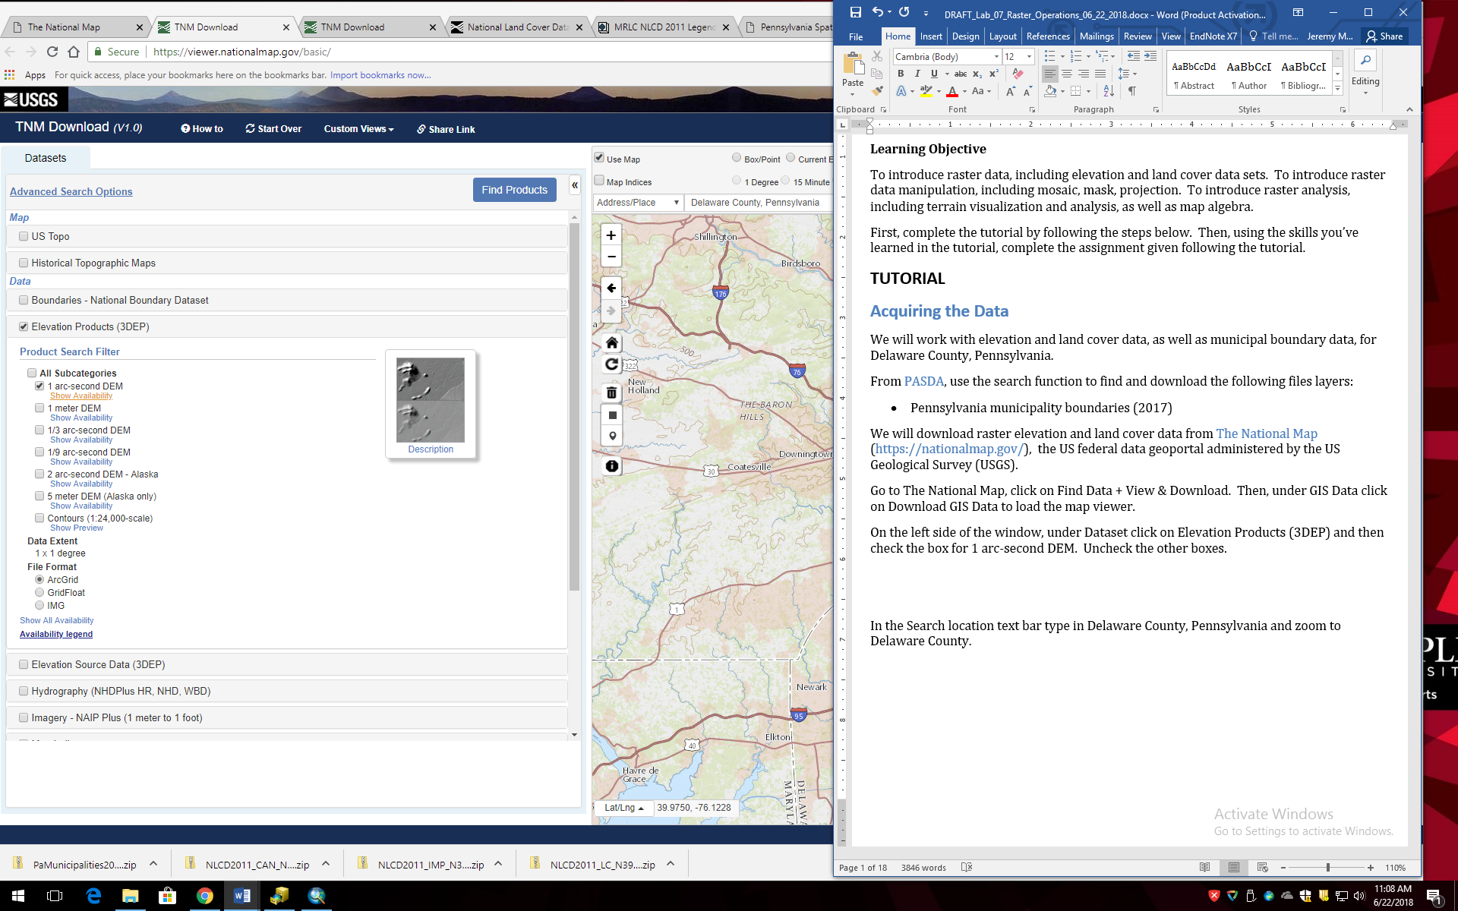

1. In the Search location text bar type in Delaware County, Pennsylvania and zoom to Delaware County.

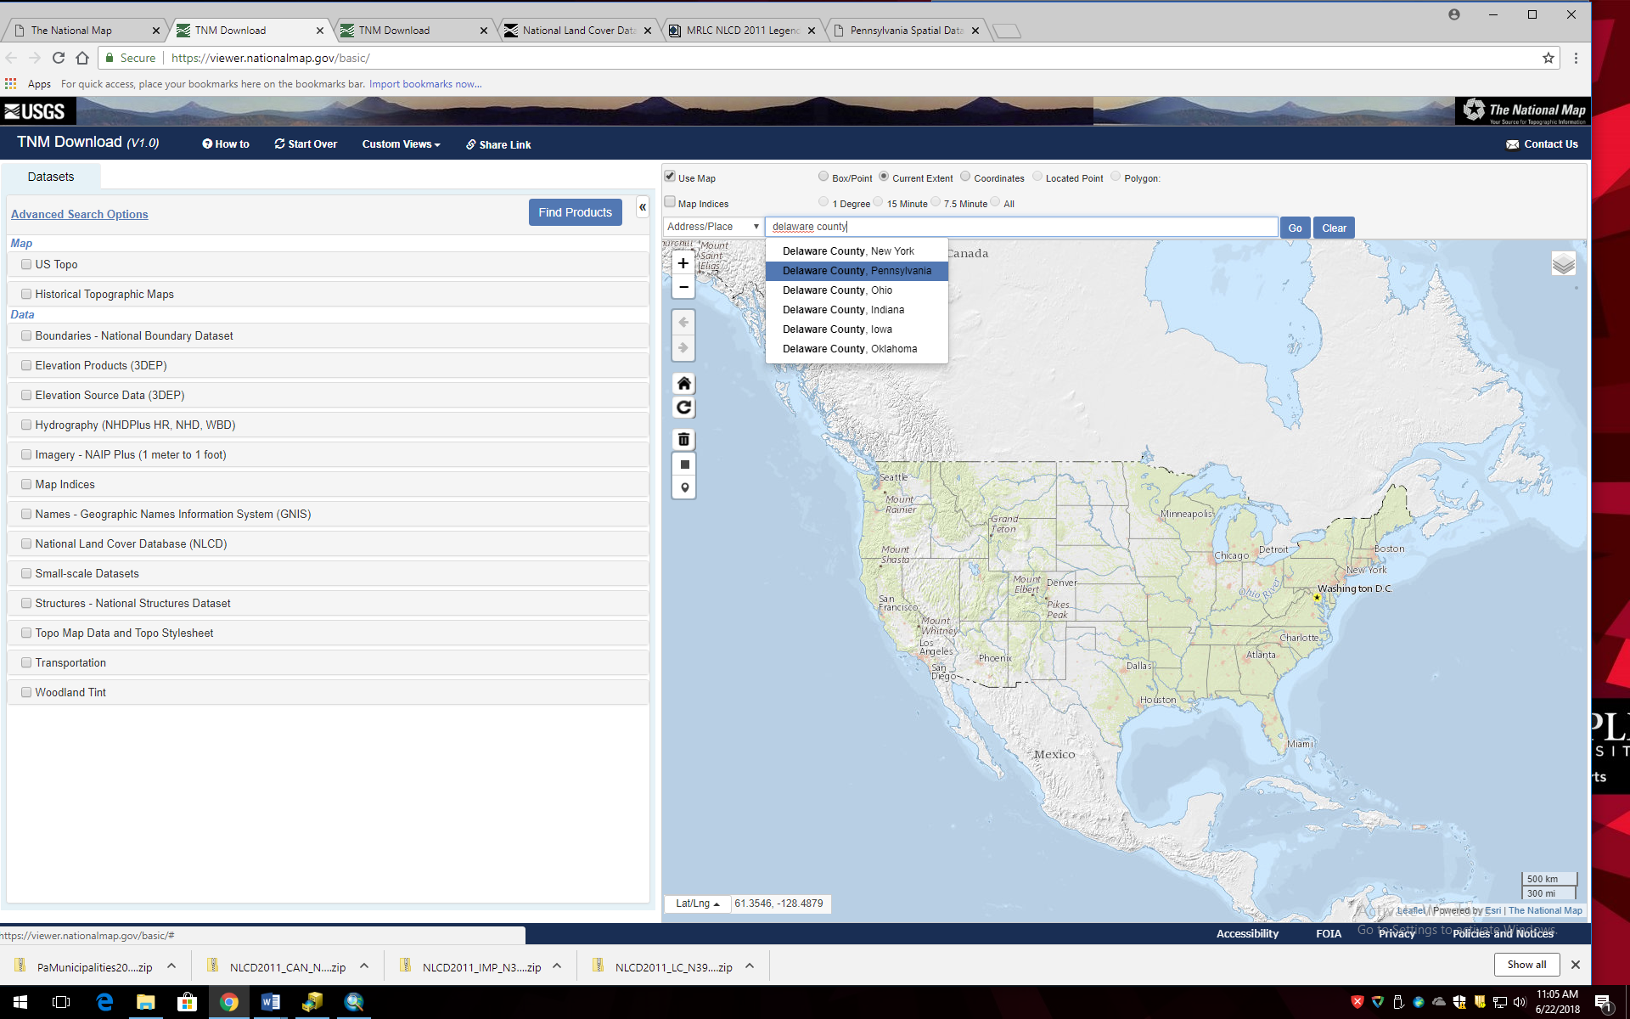

1. In the pop up box for Delaware County click on the Find Products link.

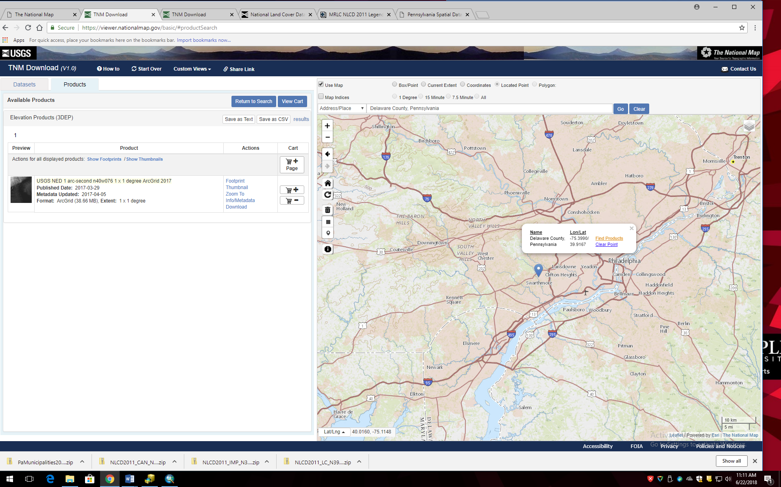

1. On the left side of the window click on Download to download the DEM in a zip format (38.66 MB).

**Because the DEM data do not adhere to county boundaries, we will need to download an additional DEM data set to cover the entirety of Delaware County.**

1. Repeat the steps above, but search for and download the 1 arc-second DEM for Montgomery County, Pennsylvania.

These steps should yield two zip files:

* + USGS_NED_1_n40w076_ArcGrid.zip
  + USGS_NED_1_n41w076_ArcGrid.zip

**Next, acquire the land cover data.**

1. While still in The National Map, click the Return to Search button at the top of the left side of the window to conduct a new Datasets search.
2. Uncheck the Elevation Products (3DEP) box.
3. Check the National Land Cover Database (NLCD) box. Then check the National Land Cover Database (NLCD) – 2011 box.

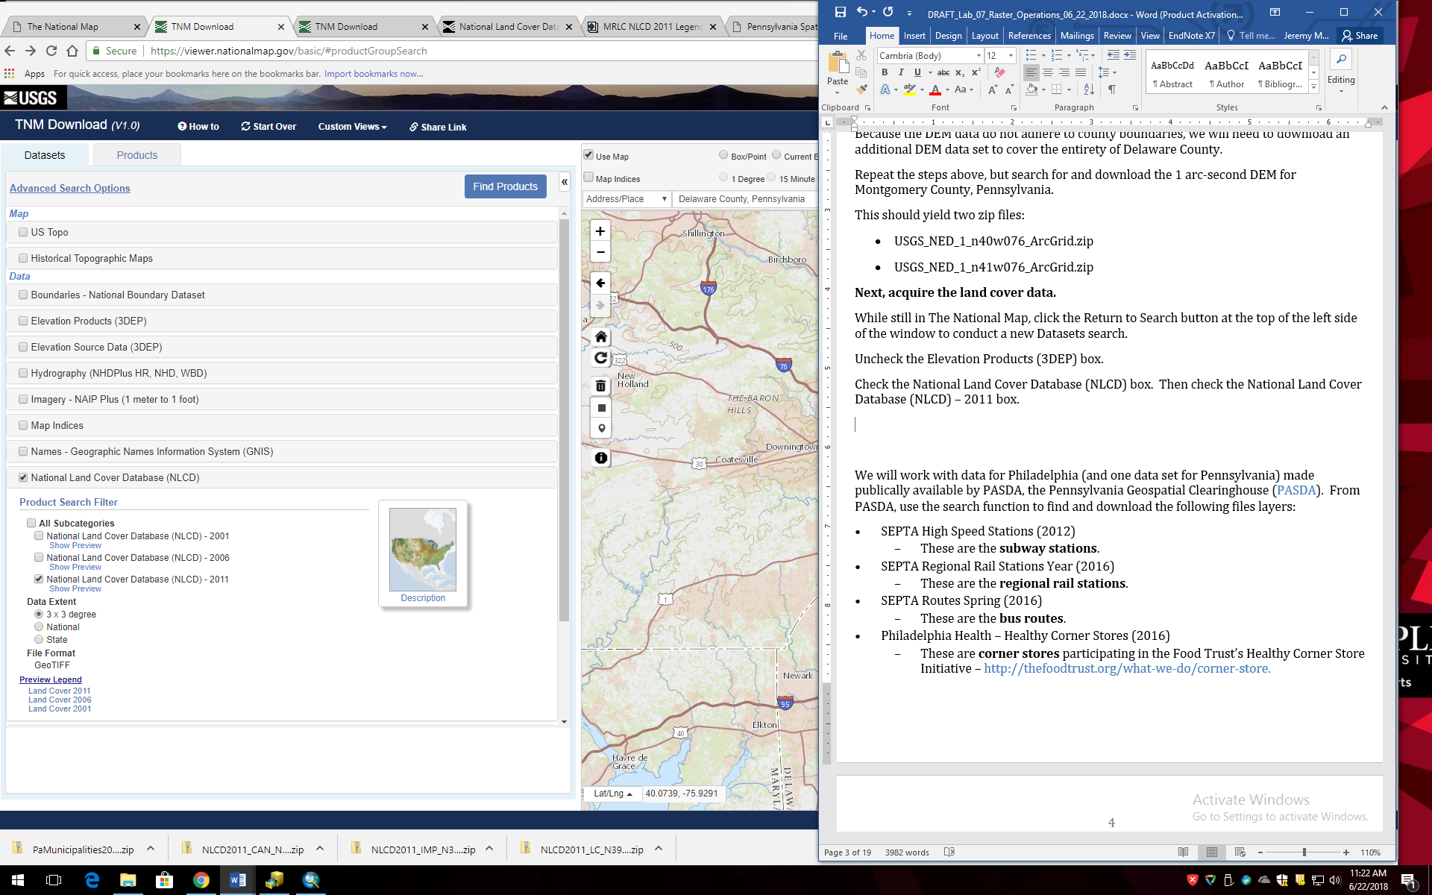

1. In the Search location bar search again for Delaware County, Pennsylvania and click on the Find Products on the Delaware County pop-up box.
2. To the right of the NLCD 2001 Land Cover (2011 Edition, amended 2014), 3x3 Degree data set, click on Download to download the zip file:

* NLCD2011_LC_N39W075.zip

Move all files to your workspace folder and unzip each of the 4 data files (2 elevation grids, land cover, and municipalities).

## Explore the Data

Open ArcCatalog and explore each of the downloaded data sets. Note that raster data are symbolized in the catalog tree using a grid symbol.

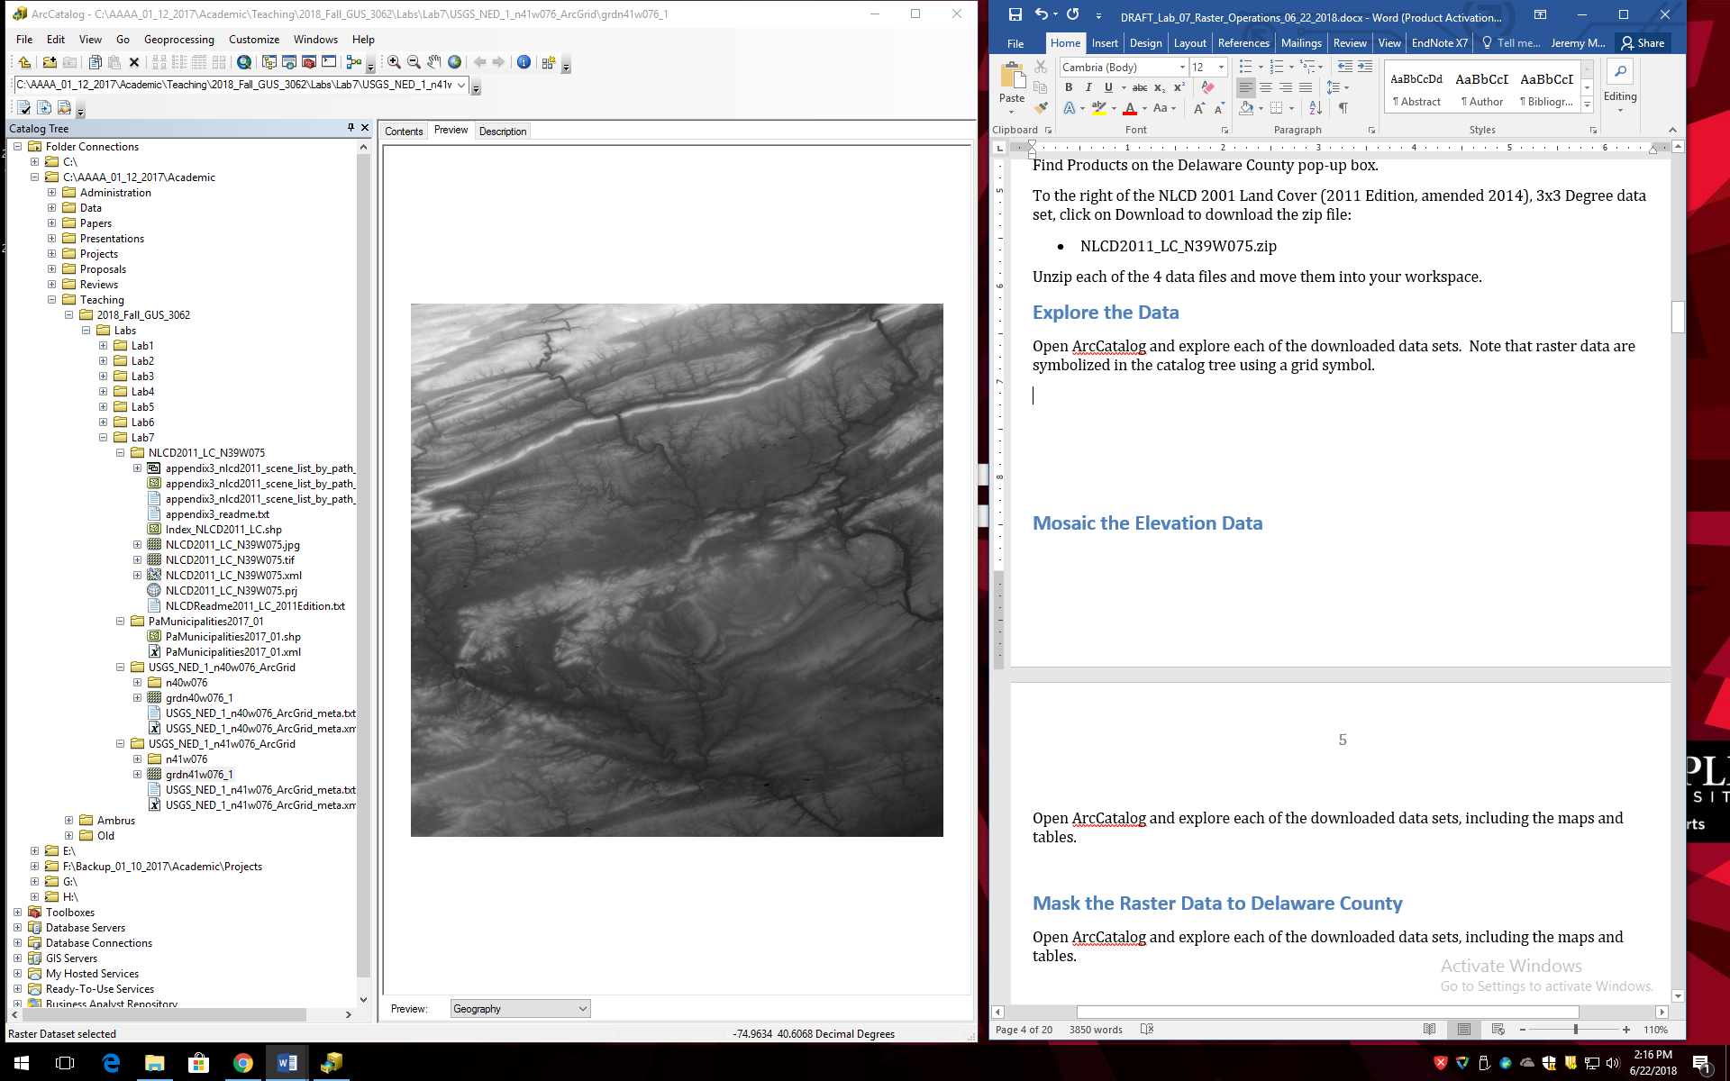

View the land cover raster (with tif file extention). Zoom in so you can see individual grid cells.

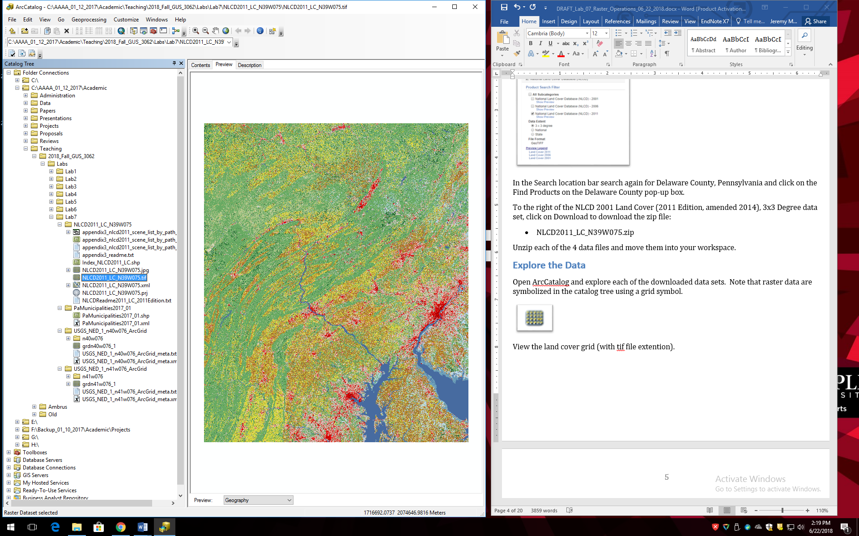

Now view the land cover attribute table. The Value field in the table, and the different colors in the image, correspond to different land cover categories, which are described on NLCD web page: <https://www.mrlc.gov/nlcd11_leg.php>.

View each of the elevation grids. Note that there are no attribute tables because the grids are a floating point data type (i.e. continuous data). The value of each grid cell is the altitude in meters above mean sea level.

## Mosaic the Elevation Data

Open ArcMap and add the two elevation grids. They should appear adjacent to each other.

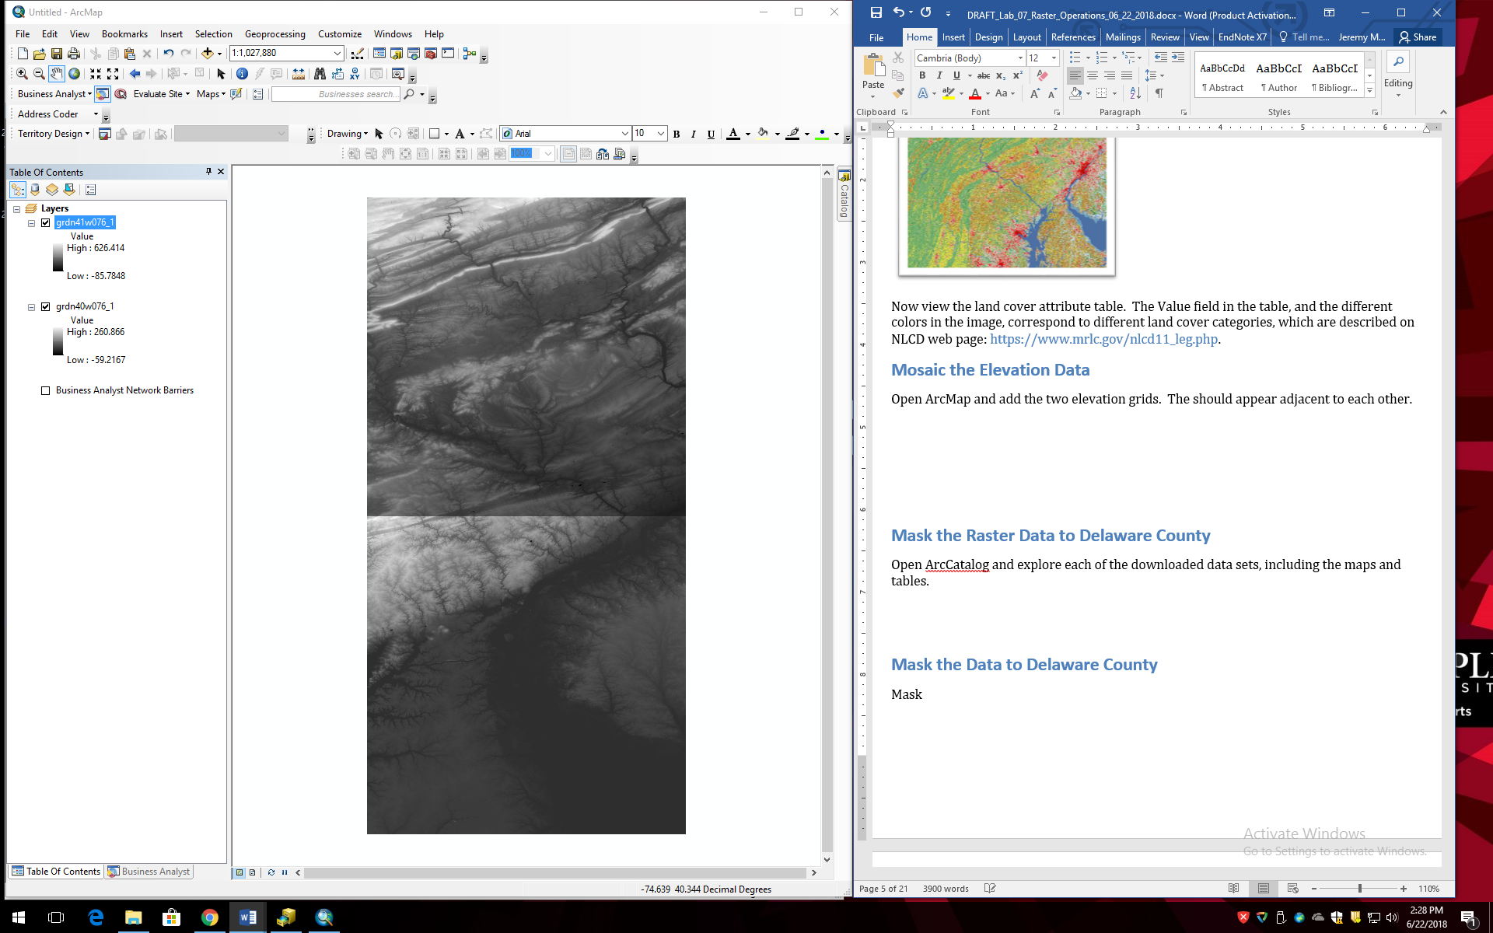

Here we will use the mosaic operation to merge the two grids into a single grid.

1. Open ArcToolbox and go to Data Management Tools→Raster→Raster Dataset→Mosaic to New Raster.
2. In the Mosaic to New Raster dialog box, for Input Rasters choose the two elevation grids, for Output Location navigate to your workspace folder. For Raster Dataset Name with Extension enter elev_mo. For Number of Bands enter 1. Press OK.

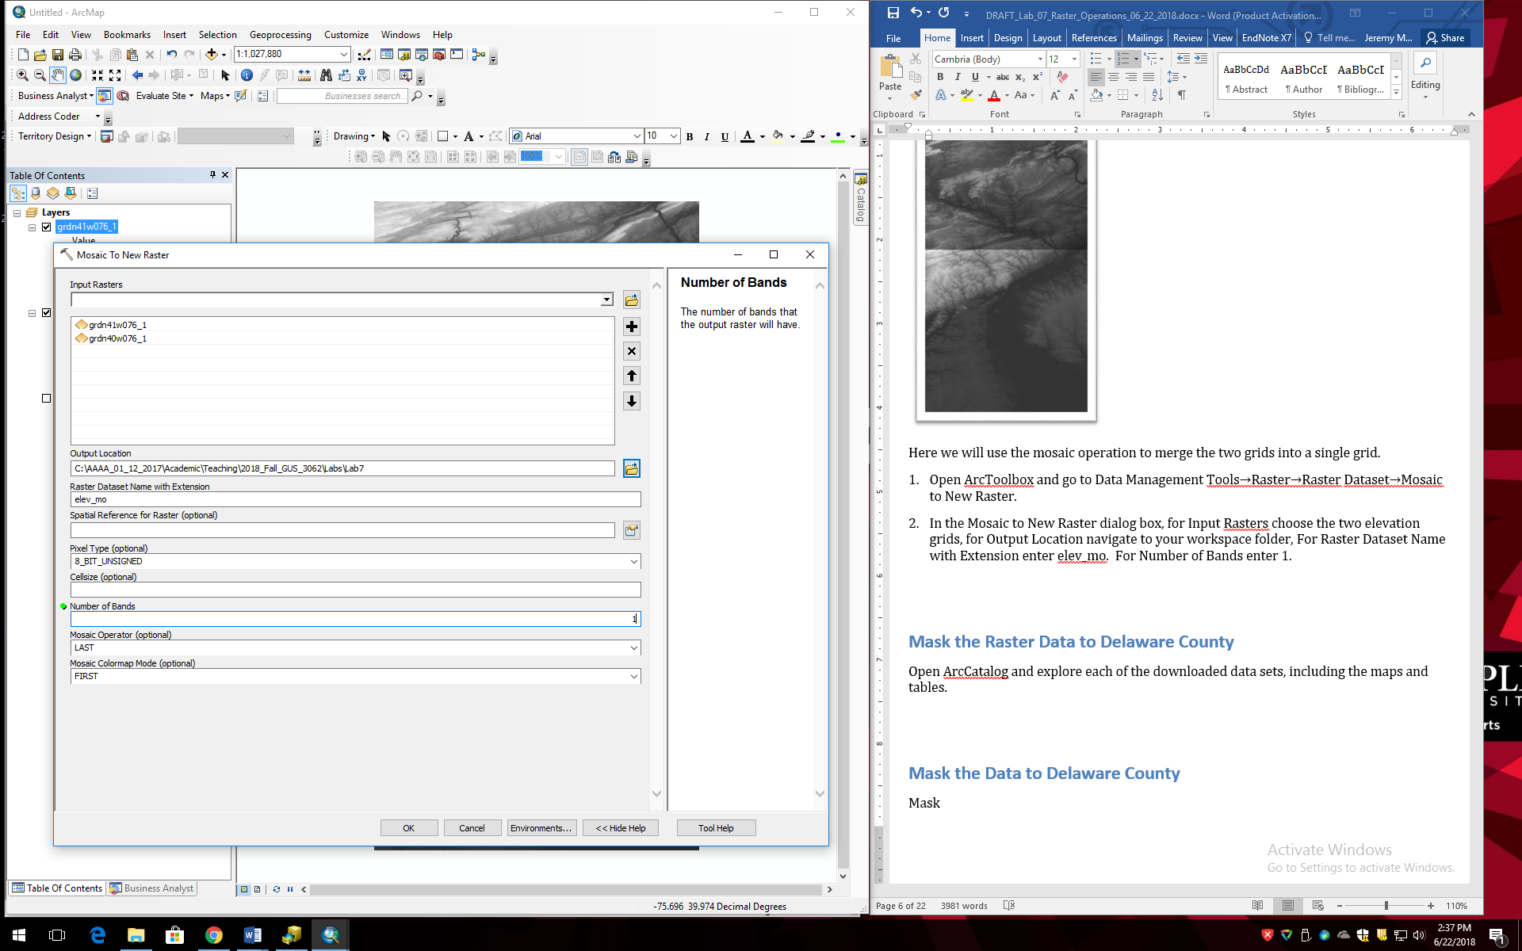

1. View the new grid. It should appear as the two original grids merged together.
2. Remove the two original elevation grids, leaving the elev_mo grid.

## Mask the Raster Data to Delaware County

Here, we will extract the elevation data for Delaware County.

1. Add the municipalities layer to ArcMap with the elevation mosaic grid.
2. Use a Select by Attribute operation to select Delaware County municipalities from the municipalities data. In the attribute table, the County field value=23 is Delaware County.
3. Export the Delaware County municipalities to its own shapefile named del_cnty.
4. Remove the original municipalities layer from ArcMap.

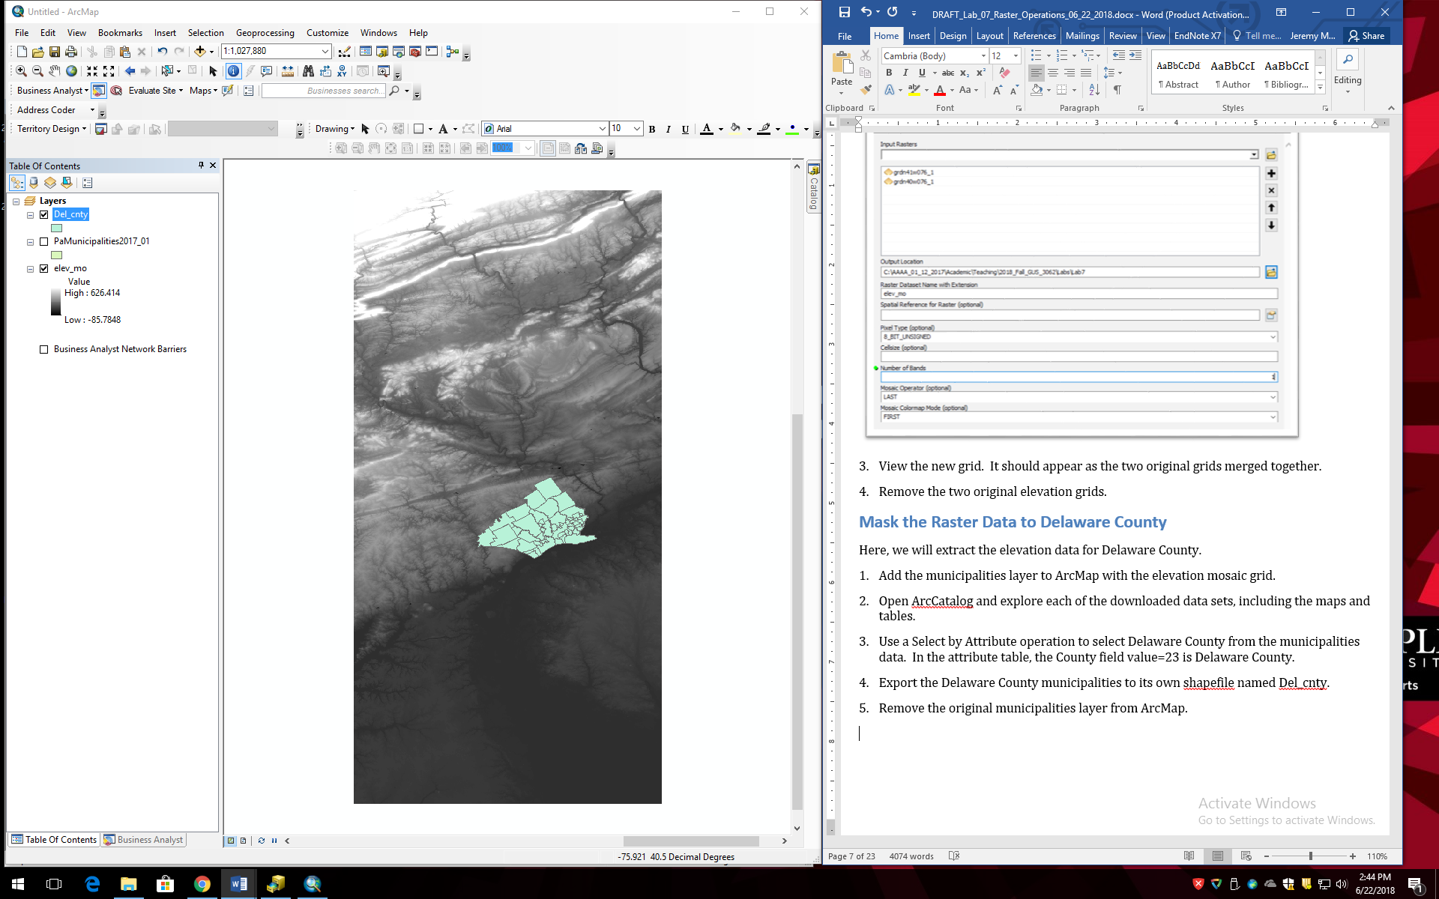

1. Turn on the Spatial Analyst raster processing extension by going to the Customize menu and Extensions and checking the box for Spatial Analyst (if it is unchecked).
2. Open ArcToolbox and go to Spatial Analyst Tools→Extraction→Extract by Mask.
3. In the Extract by Mask tool, for Input raster choose the elevation mosaic grid and for Input raster or feature mask data choose del_cnty. Name the output raster del_elev.
4. Turn off all the layers except del_elev and view the new raster.

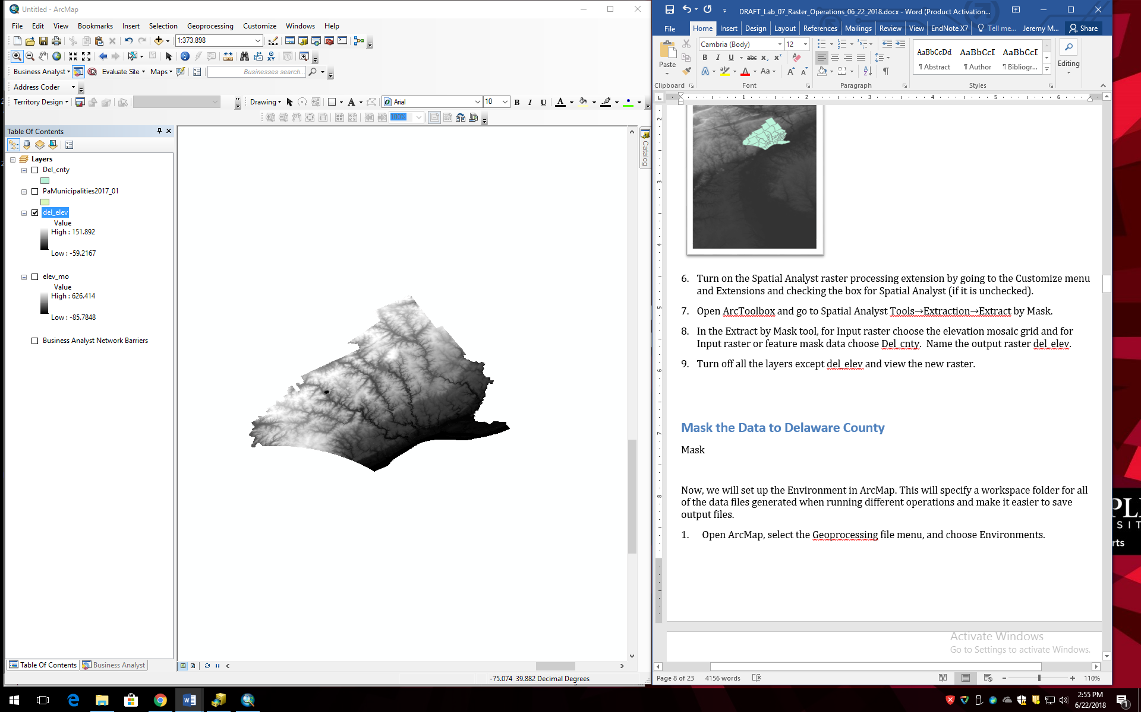

**Now, we will mask the land cover data to Delaware County, but we will need to open a new ArcMap session because the land cover grid is in a different CRS.**

1. In ArcMap go to the File menu and choose New. Click OK. Do not save changes.
2. Add the land cover grid with the tif file extension.
3. Add the del_cnty layer.
4. Repeat the steps above to mask the land cover data to Delaware County. Call the output raster del_land.

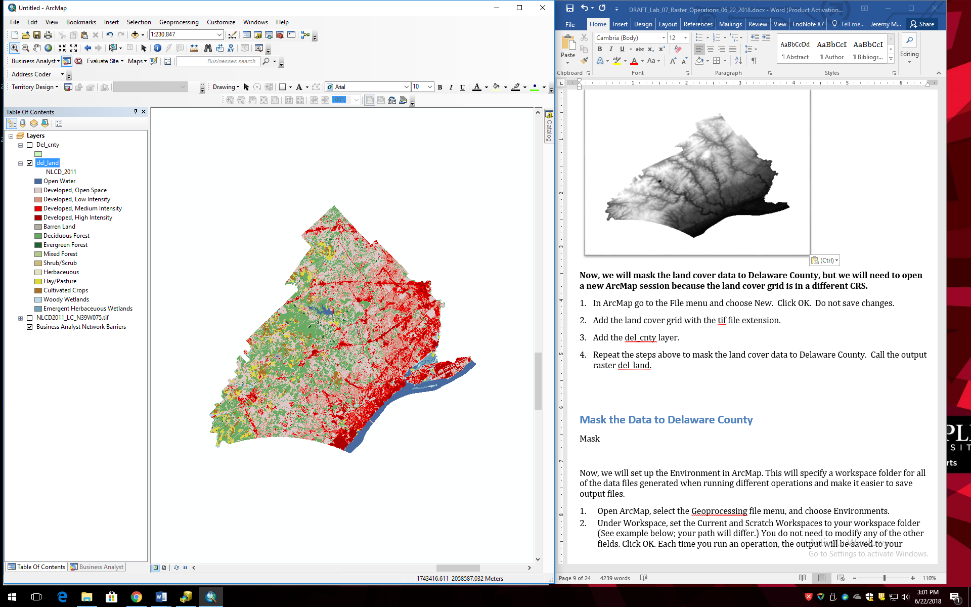

1. Close ArcMap and do not save.

## Reproject the Data

View the del_elev and del_land grids in ArcCatalog. They are clearly different shapes because they are in different CRSs, as you can confirm by going to the Layer Properties of each. Here, we will reproject all three data sets (the del_elev and del_land grids, and the del_cnty shapefile) into UTM.

1. In ArCatalog, reproject the del_cnty shapefile into NAD_1983_UTM_Zone 18N.
2. Reproject for raster data uses a different tool. Go to ArcToolbox→Data Management Tools→Projections and Transformations→Raster→Project Raster.
3. The tool dialog box is similar to the vector Project tool. Convert both the del_elev and the del_land rasters to NAD_1983_UTM_Zone 18N. Name the new grids del_elev_utm and del_land_utm, respectively.

## Creating a Hillshade

A hillshade is a grid that encodes a hypothetical reflectance value off an elevation surface given the position of a virtual light source. It allows for the visual representation of the terrain as though you were viewing the surface from an airplane.

1. Open ArcMap and add the del_elev_utm grid.
2. To create a hillshade grid, go to ArcToolbox→Spatial Analyst Tools→Surface→Hillshade. For Input raster choose del_elev_utm. Name the output hill_1. Leave the other defaults and click OK.
3. In the resulting hillshade you should be able to see the more rugged terrain in the north and west of the county and the stream valleys which flow south towards the Delaware River.

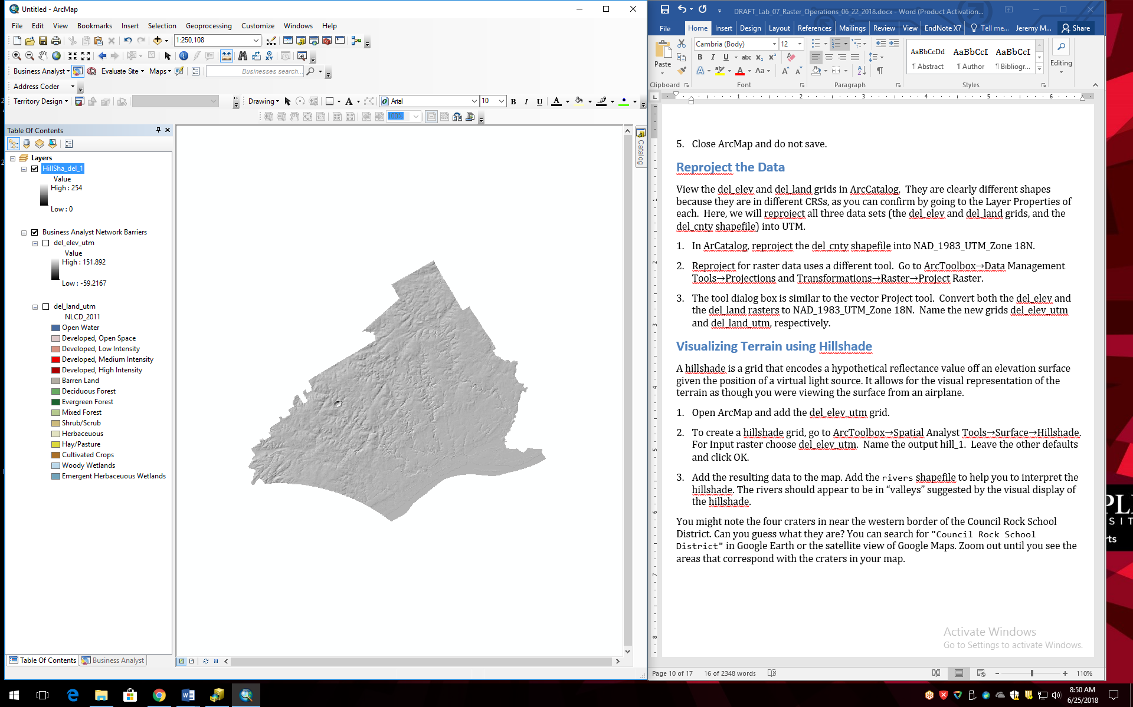

1. You can also exaggerate the vertical height to improve the visualization of the terrain. Perform another hillshade but this time change the Z factor to 2 or 3. Experiment with other parameter changes in the hillshade, including the virtual location of the light source by tweaking Altitude and Azimuth settings. Examine the effects of changing parameters on the resulting hillshade layer.

## Visualizing Terrain

Impressive visualizations of terrain can be easily generated by using the elevation and hillshade grids together. Turn off everything except the elevation and your preferred hillshade grids from your experiments in the last section, and order your layers so that the hillshade is ‘on top’.

1. Open the Layer Properties for the elevation grid and select the Symbology tab. (Notice how it differs slightly from the Symbology tab for vector layers that we have been working with in previous lab exercises.) Choose a multi-color color ramp like the one shown here:

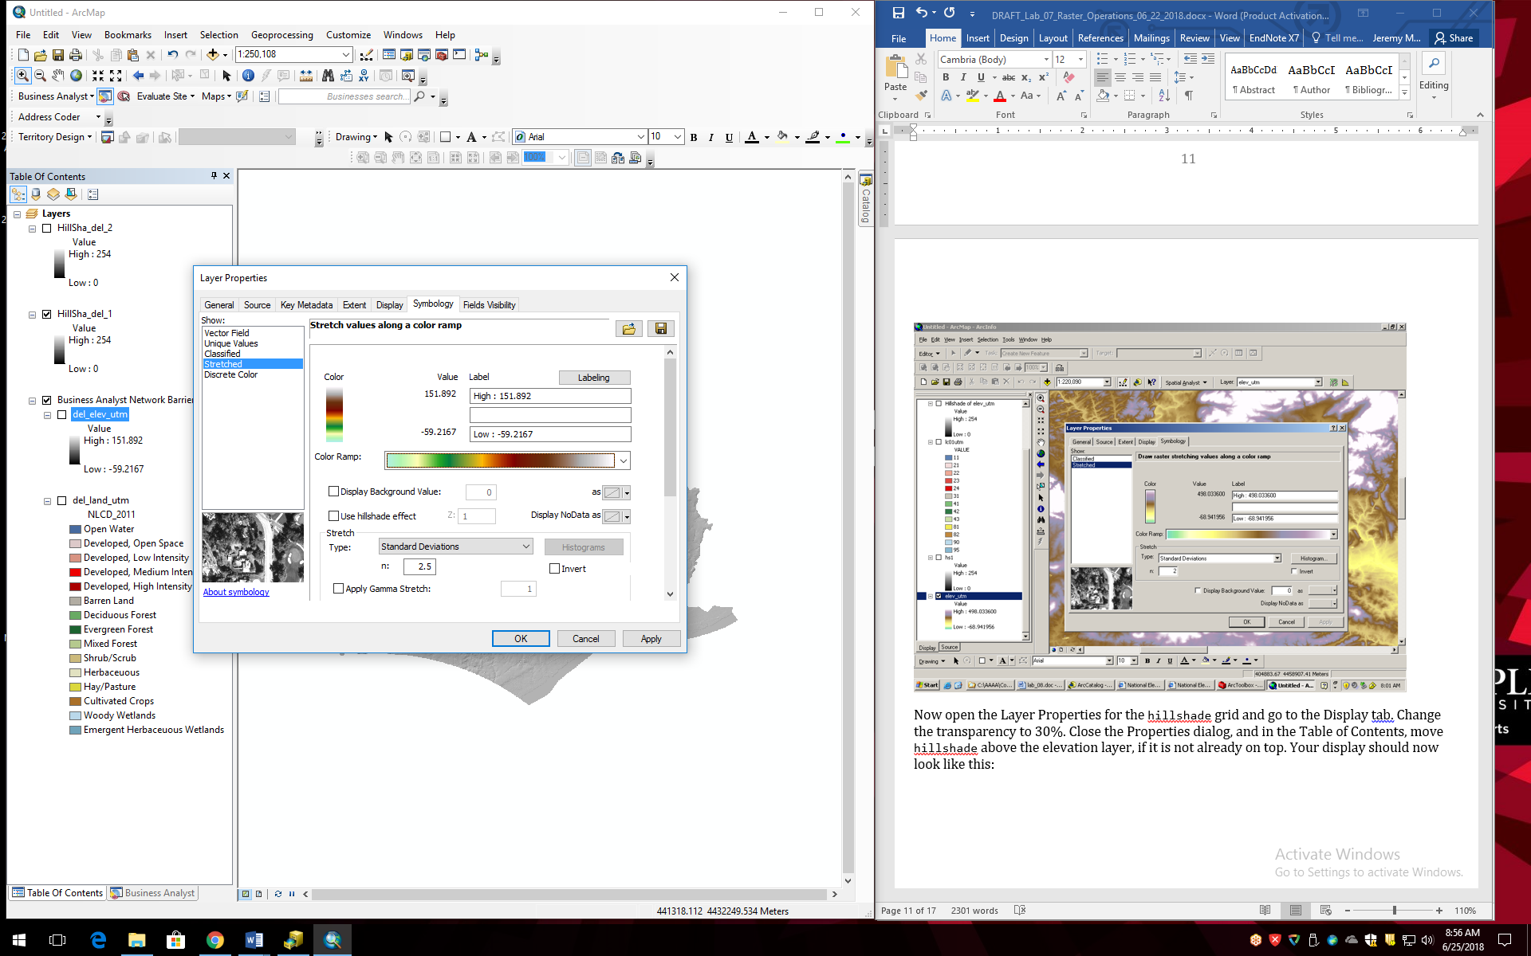

1. Now open the Layer Properties for the hillshade grid and go to the Display tab. Change the transparency to 30%. Close the Properties dialog. Your display should now look something like this:

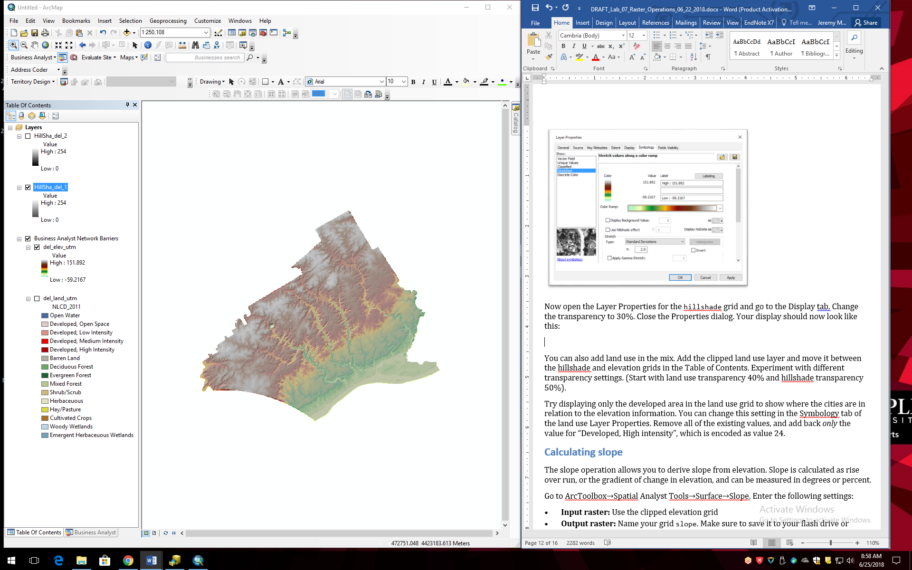

1. You can also add land use to further enhance the visualization. Add the del_land_utm grid to ArcMap and move it between the hillshade and elevation grids in the TOC. Experiment with different transparency settings for the land use and hillshade grids so that both can be seen simlutaneously. (Start with land use transparency=40% and hillshade transparency=50%).

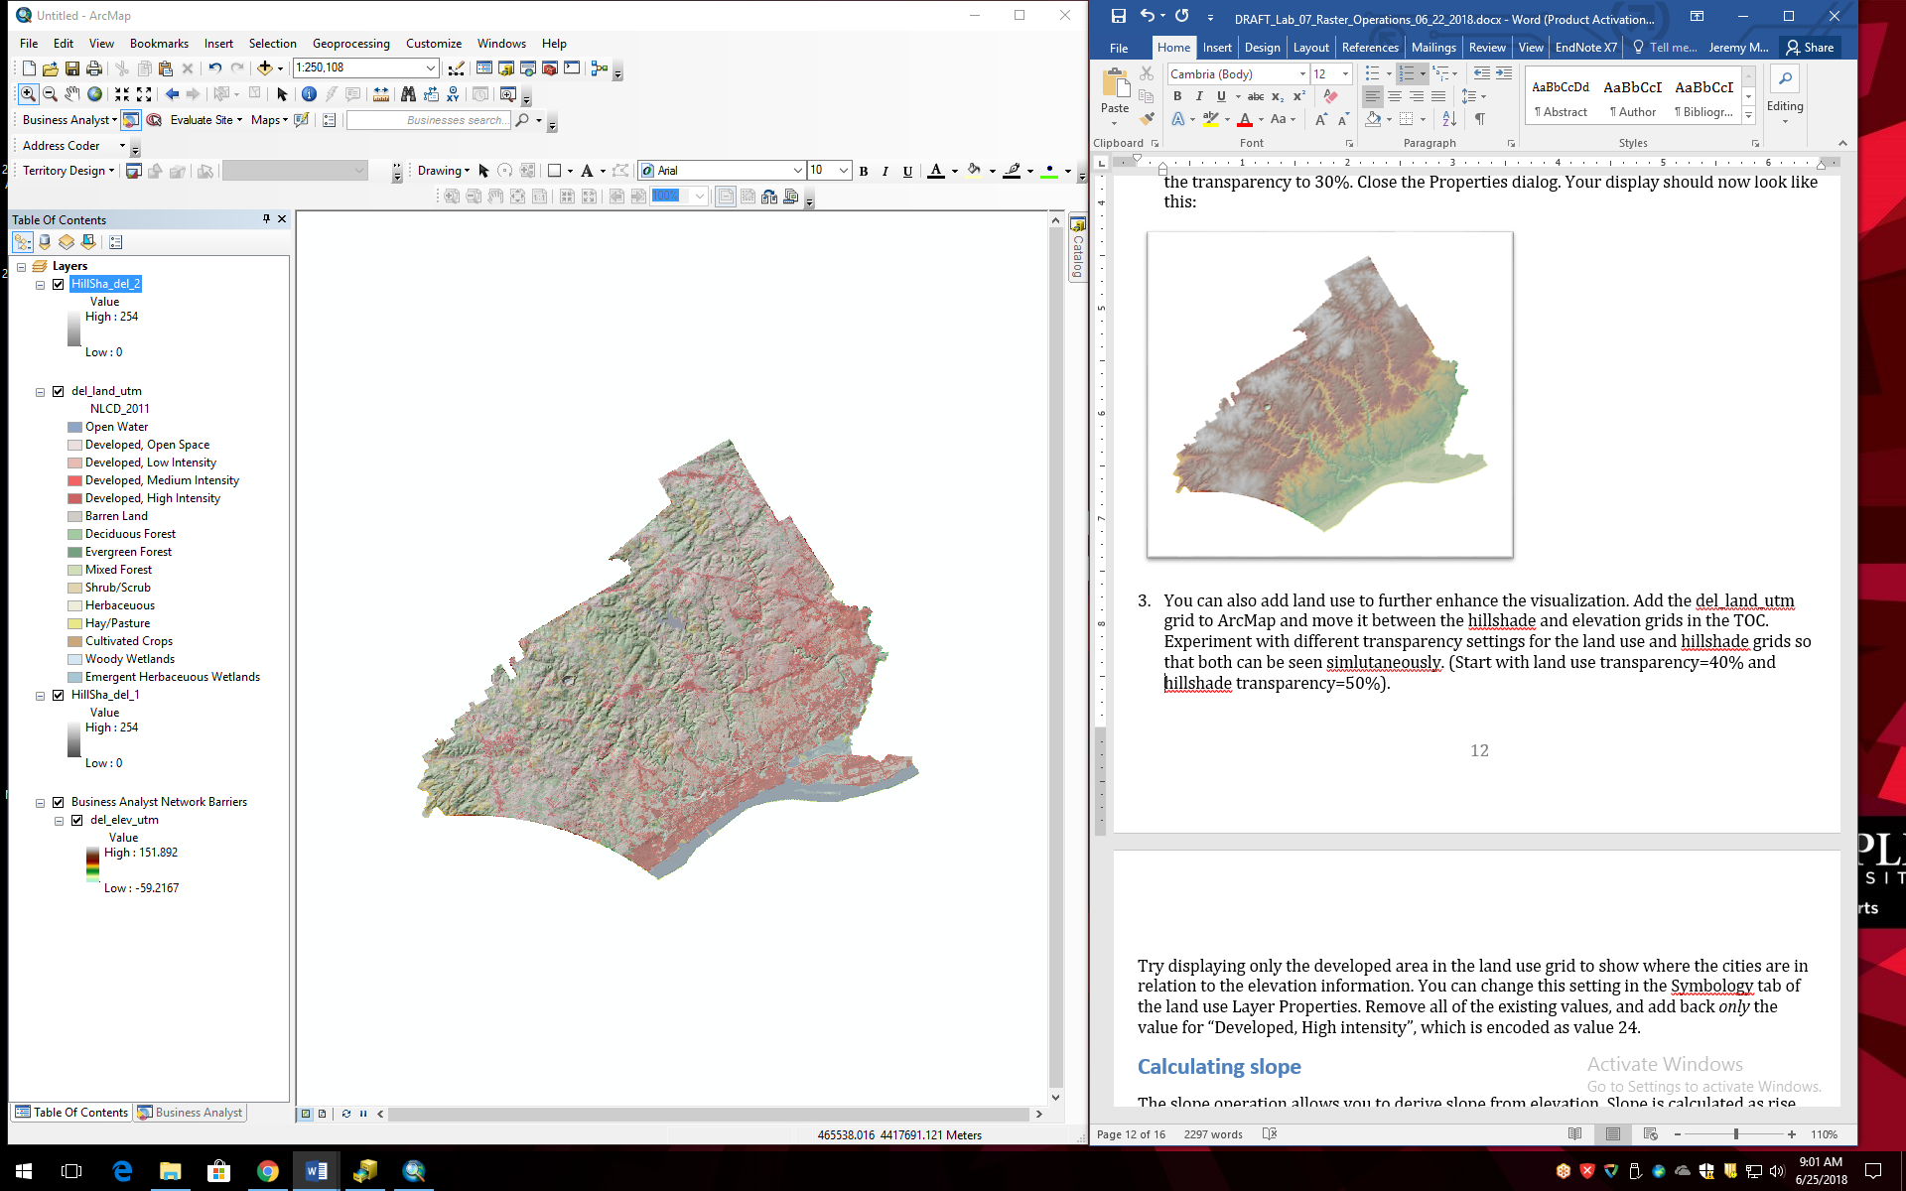

1. Now try displaying only the developed area in the land use grid to show where the cities are in relation to the elevation information. You can change this setting in the Symbology tab of the land use Layer Properties. Select all the land cover categories except for the Developed, High Intensity land covers and press Remove. You may want to adjust the color setting, or the transparency setting in the Display tab to make it less transparent (say, 20%). Press OK.

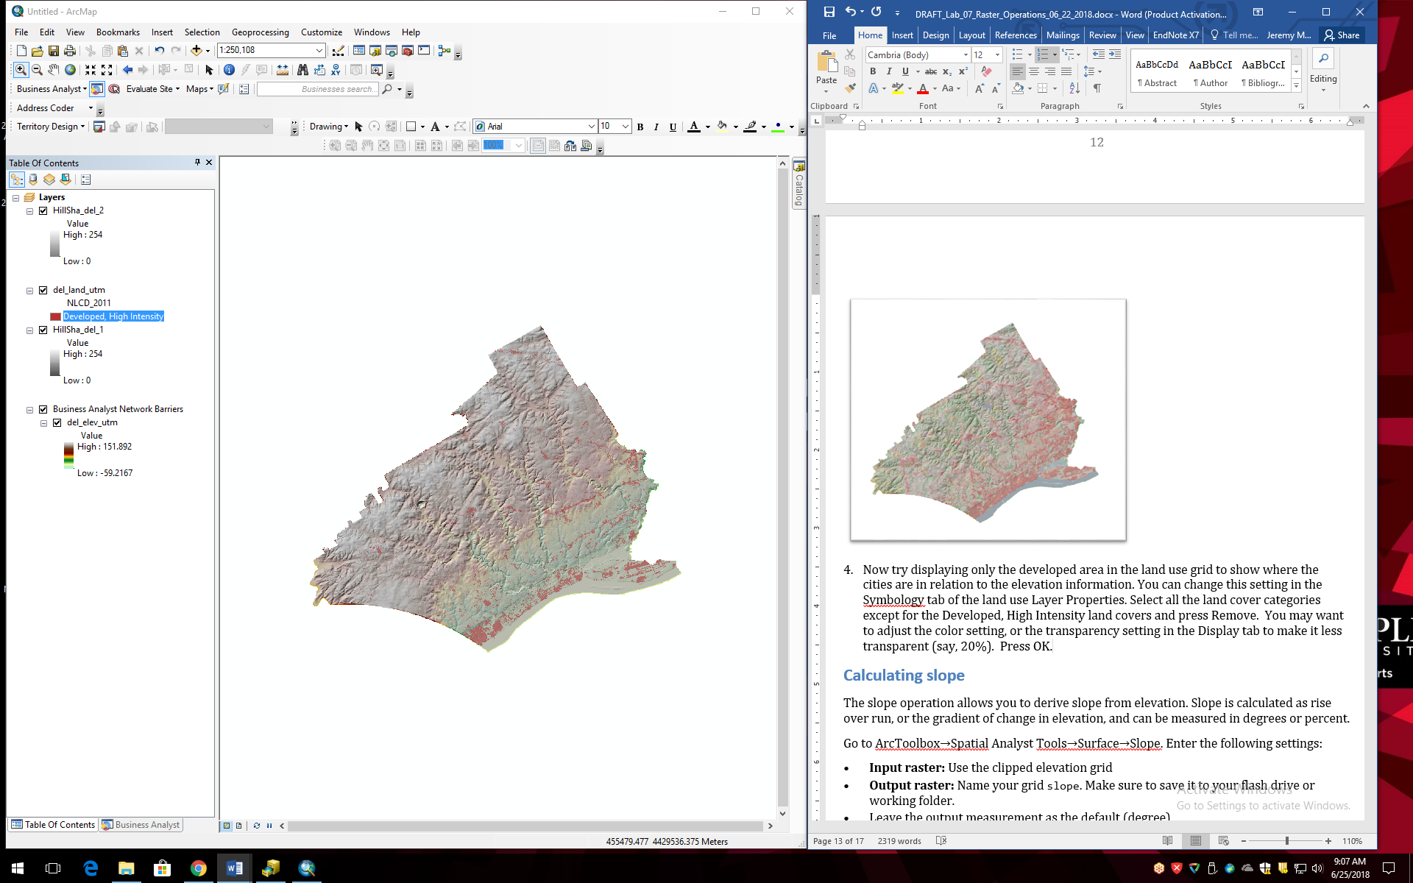

## Calculating Slope

The slope operation allows you to derive slope from elevation. Slope is calculated as rise over run, or the gradient of change in elevation, and can be measured in degrees or percent.

1. Turn off the layers except for del_elev_utm.
2. Go to ArcToolbox→Spatial Analyst Tools→Surface→Slope. For Input raster choose del_elev_utm. Name you grid slope. Leave the Output measurement as the default (degree). Press OK.
3. Examine the resulting slope grid. Note that the steepest slopes occur along the streams.

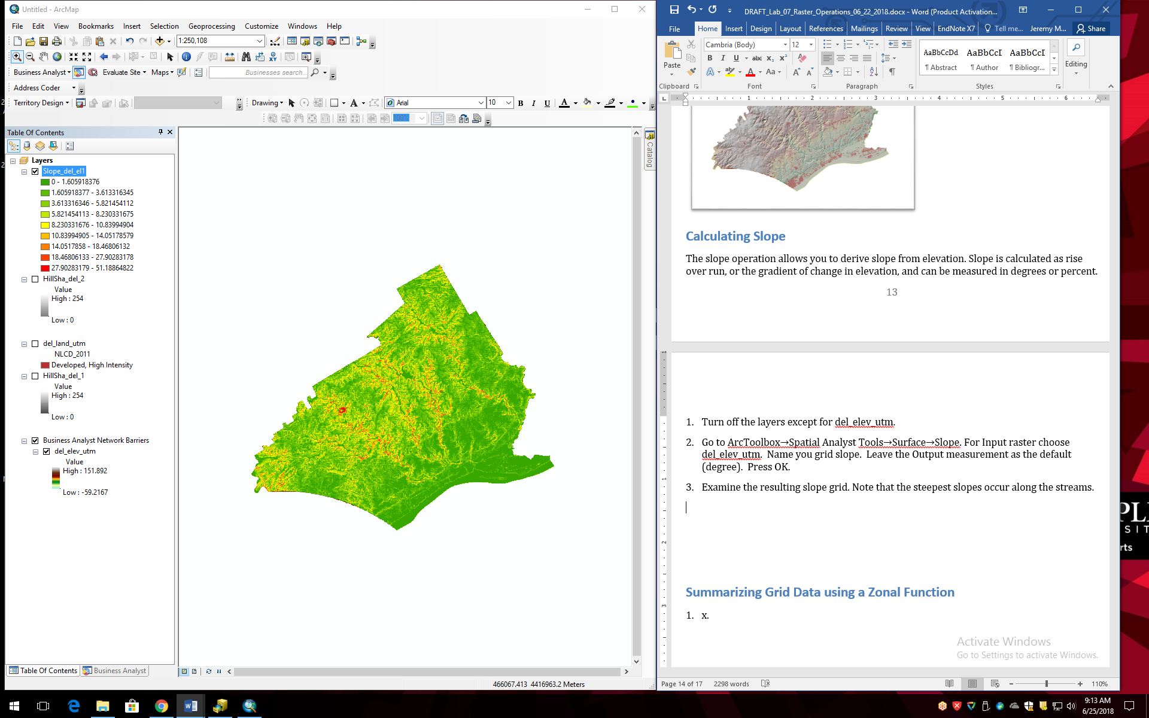

## Summarizing Grid Data using a Zonal Function

A zonal function allows you to summarize the values of raster grid cells in zones specified in a second file. The zone file can be a raster or vector format. As an example we will summarize the slope by land use category in Delaware County.

1. Turn off all the layers but the slope and land use grids.
2. Go to ArcToolbox→Spatial Analyst Tools→Zonal→Zonal Statistics as Table. For Input raster or feature zone data choose del_land_utm. The Zone field should default to Value,since this is the only data associated with this raster. For Input value raster choose the slope grid. Name the output lu_slope. Press OK.
3. Open the resulting table. (If you don’t see the new table, click on the List by Source tab in the TOC.) The zonal function generates a table in which each record is a zone (here, land use) and the fields contain information on various aggregate functions such as the minimum, maximum, range, mean, standard deviation, and sum (which is not applicable here) of the values (here, slope) for each zone. For example, the MEAN field reports the mean slope value for each land use category. The mean slope for Developed, High Intensity land (Value=24) is 1.55°, whereas for Deciduous Forest land (Value=41) the mean slope is 6.41°.

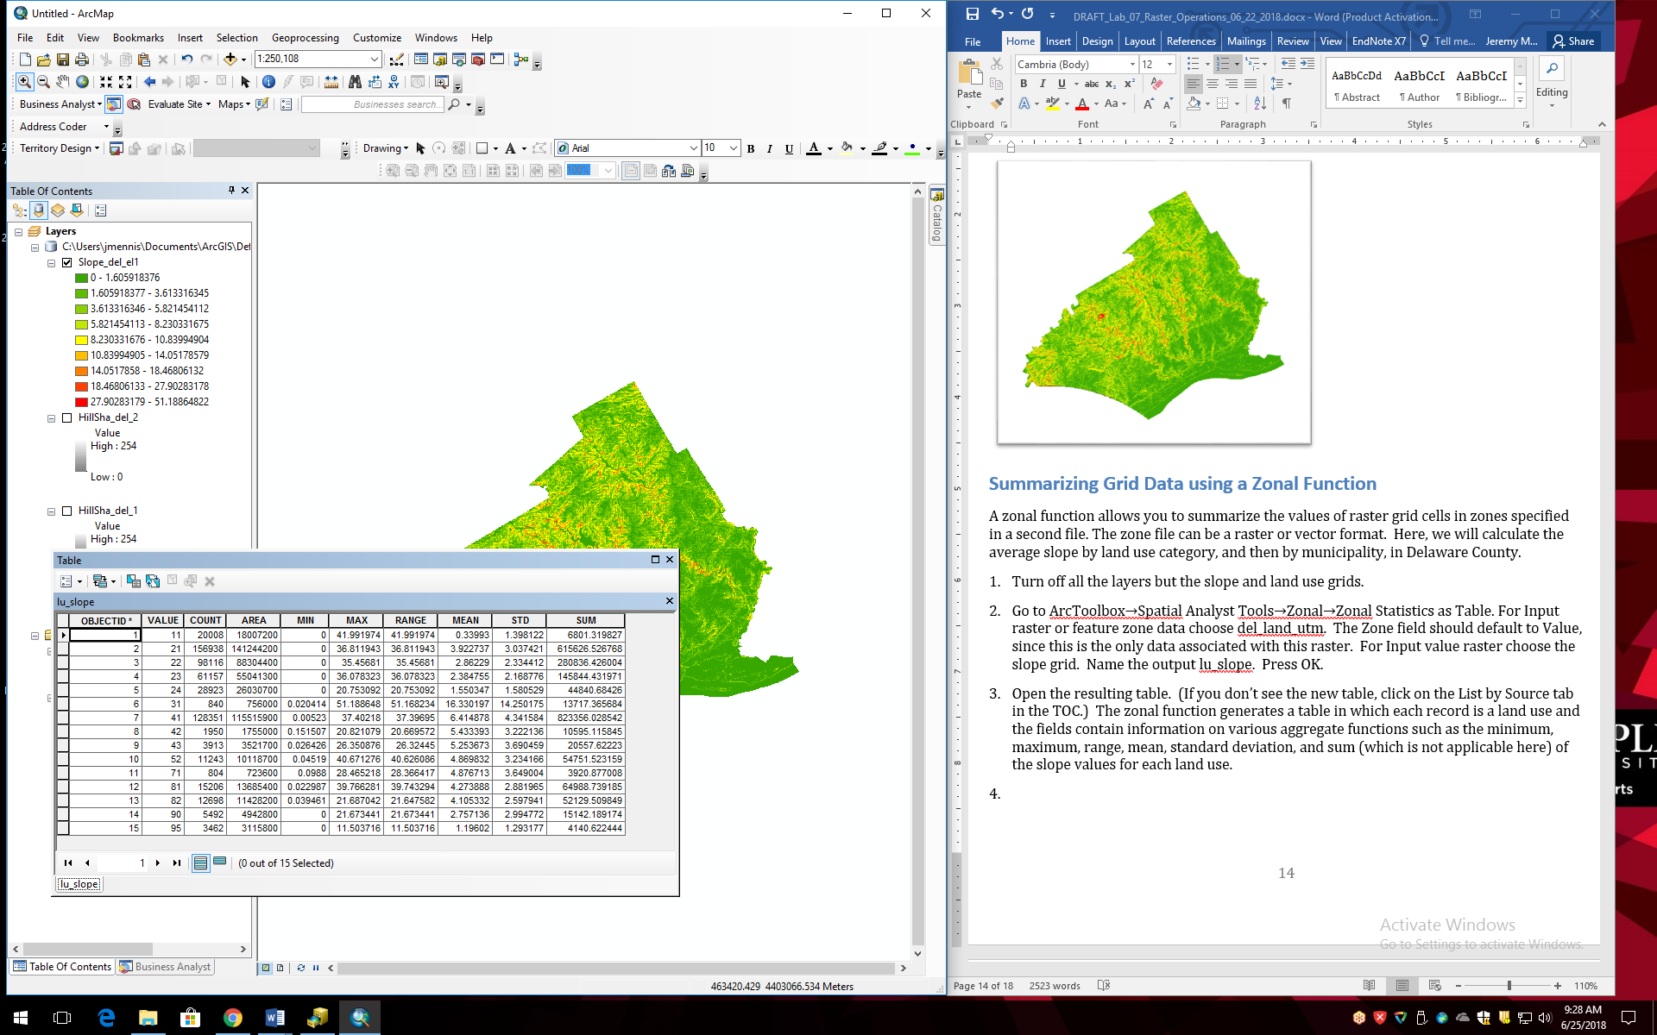

1. The COUNT field is the number of grid cells in that zone (here, land use) and the AREA field is the area. For instance, the number of grid cells in the Developed, High Intensity category in Delaware County is 28,923, and the total area of Developed, High Intensity land is 26,030,700 square meters (since the data are in the UTM CRS, which uses meters as units).

It is also possible to use a vector data layer as the zone layer in a zonal function. Here, we will summarize the slope by municipality in Delaware County.

1. Add the del_cnty_utm layer to ArcMap. Repeat the Zonal Statistics as Table function. For Input raster or feature zone data choose del_cnty_utm. For Zone field, choose MUNICIPAL1, as this is the name of each municipality (we want an output table where each record represents a unique municipality). For Input value raster choose the slope grid. Name the output mun_slope. Press OK.
2. View the output table. It should have 47 records – one for each municipality.

Let’s visualize the results by creating a choropleth map of the mean slope by municipality.

1. Join the mun_slope table to the del_cnty_utm attribute table using the MUNICIPAL1 field to facilitate the join.
2. Create a choropleth map of the MEAN field (i.e. the mean slope of each municipality). Use a quantile classification and choose a sequential color scheme. You can see that the municipalities with the average steepest slopes occur in the central and western part of the county.

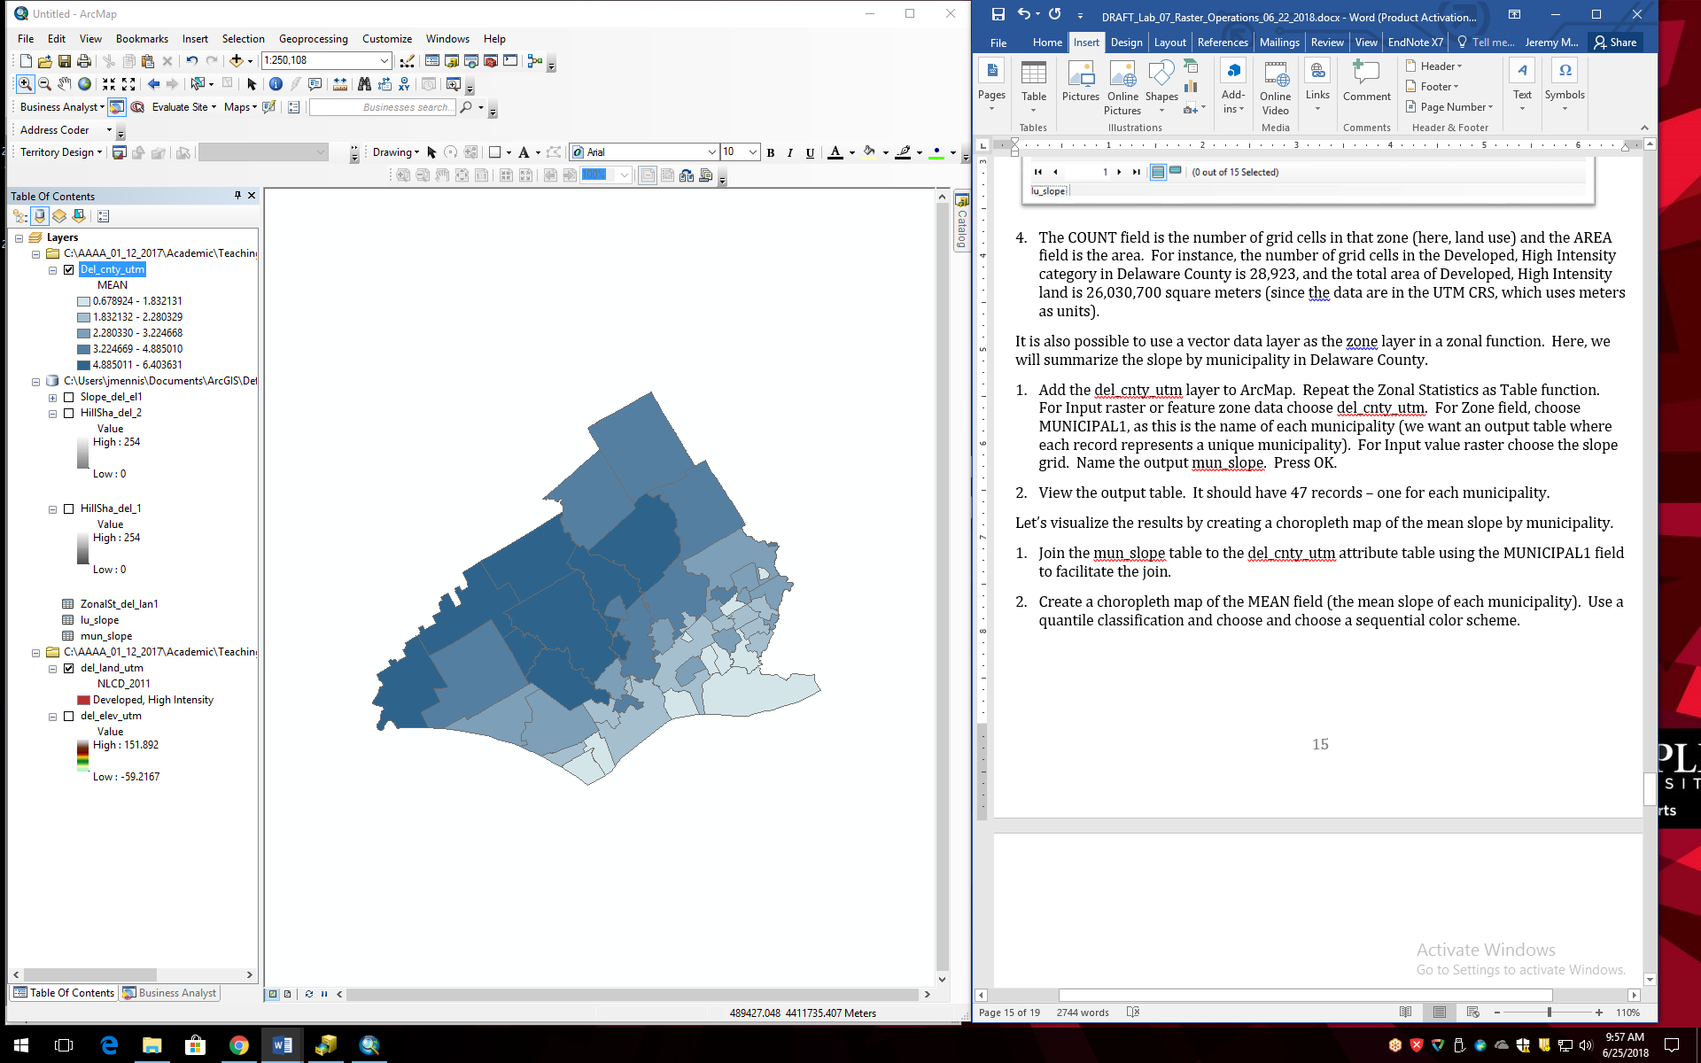

# ASSIGNMENT

## Objective

Flooding in Delaware County is a problem, particularly in the southeastern portion where several streams flow into the Delaware River. Flooding is made worse by steep slopes and the presence of impervious surface cover (i.e. developed land cover surfaces which do not allow water to infiltrate, such as pavement and rooftops), both of which contribute to rapid, high volumes of runoff during storm events.

The objective is to identify municipalities that might be key contributors to flooding in Delaware County. Specifically, answer the following questions:

Which municipalities in Delaware County, Pennsylvania have a *median* percent impervious surface area of at least 50%?

Which municipalities in Delaware County, Pennsylvania have a *mean* percent slope of at least 5 degrees?

# Deliverables

**Turn in a report in the format described in the syllabus.**

Be sure to include the following information:

1. A list of the municipalities which have a median percent impervious surface area of at least 50%.
2. A list of the municipalities which have a mean percent slope of at least 5 degrees.
3. A map of the terrain that simultaneously shows the hillshade and elevation with the grid cells with a percent impervious surface > 50% overlain.
4. A choropleth map of the median percent impervious surface by municipality.

The **Introduction** section should state the research objective and the relevant criteria for identifying the municipalities.

The **Data and Methods** section should state the data sets used in the analysis, from where those data were acquired, and the GIS operations employed.

The **Results** section should state the results (i.e. the lists of the municipalities that meet each of the criteria). The maps should be cited in the text here.

The **Discussion** section should state an interpretation of the results (i.e. what parts of the county have steeps slopes or high impervious surface percentages), limitations of the analysis, and how the analysis could be improved or expanded.

The **Tables** **and Figures** section should contain the maps, each on a separate page with a caption. The maps should be cited in the text.

# Getting Started

You can use some of the products you have created in the tutorial for the assignment. You will also need to download a new raster data set on impervious surface.

1. Download the 2011 NLCD Impervious Surface data from The National Map (you can follow the same directions you used to download the land cover data, above, but instead of the land cover data download the Percent Developed Imperviousness data from the available products). The value of each grid cell in the impervious surface grid is the percentage of the grid cell covered by impervious surface. Mask the impervious surface data to Delaware County, and convert it to the UTM CRS.
2. Use the elevation grid and the hillshade grid you created, in combination with the impervious surface grid, to generate a map of the terrain that simultaneously shows the hillshade and elevation with the percent impervious surface layer overlain.
3. Use the output table from the Zonal Statistics as Table function you completed in the tutorial using the municipalities (zone layer) and the slope grid (value grid) to identify the municipalities which have a mean percent slope of at least 5 degrees.
4. Use a Zonal Statistics as Table function using the municipalities layer (as the zone layer) and the impervious surface grid (as the value grid) to generate a table from which you can identify the municipalities which have a median percent impervious surface area of at least 50%.
5. Join the output table from the previous Zonal Statistics as Table function to the municipalities attribute table to generate a choropleth map of the median percent impervious surface by municipality.